# ICT2103 T1 Lab 2

## CREATE USER “kenneth”@localhost IDENTIFIED BY “root”;

## CREATE DATABASE IF NOT EXISTS kennethdb;

## SELECT * FROM students;

## INSERT (sid, name) VALUES (2101313, “Kenneth”);

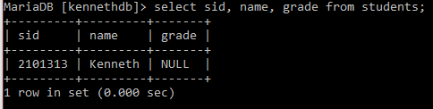

## INSERT (sid, name) VALUES (2002222, “Valtteri”);

## INSERT (sid, name) VALUES (2003333, “Russell”);

## UPDATE students SET grade = “A+” WHERE name = “Valtteri”;

## UPDATE students SET grade = “A-“ WHERE name = “Valtteri”;

## DELETE FROM students WHERE name = “Valtteri”;

## DELETE FROM students;



## DROP DATABASE IF EXISTS kennethdb;

